Predicting annual dengue incidence by using climate data and imported cases data in Taiwan

Developer: I-hsuan Wu

2019/08/09

Data

* “dengue data.csv”:

from國網中心資料集平台 (<https://scidm.nchc.org.tw/en/>)

* “1999-2015 Kaohsiung+Tainan_local+import_mothly average.csv”

From data “dengue data.csv“

→ use excel to clean data, just reserve year+month+ Imported+ MOI_County_living

→ use excel to separate file to “import-Kaohsiung”, “local-Kaohsiung**”,** “import-Tainan”, “local-Tainan**”**

→ use excel averageif() to calculate 1999-2015 monthly dengue cases

* "1999-2015 L4-Kaohsiung+Tainan.csv" (dengue cases)

From data “dengue data.csv“

→ use excel to clean data, just reserve year+month+ Imported+ MOI_County_living

→ use excel to separate file to “import-Kaohsiung”, “local-Kaohsiung**”,** “import-Tainan”, “local-Tainan**”**

→ use excel sumif() to sum local cases from April in the given year to March next year

* “1998-2019 KaohsiungRMAX+TMIN.csv” (weather data)

From Dr. YUAN & 觀測資料查詢系統(<http://e-service.cwb.gov.tw/HistoryDataQuery/>) –year data

“import-Kaohsiung”, “local-Kaohsiung**”**

→ put import cases inside

→ use sumif() to sum I4_9……..(imported cases from April to June)

* “1999-2018.daily.data” (weather data)

from Dr. YUAN

* “1999-2015 TainanRMAX+TMIN.csv” (weather data)

“1999-2018.daily.data”

→ use excel filter function to choose maximum rainfall and minimum tempreture

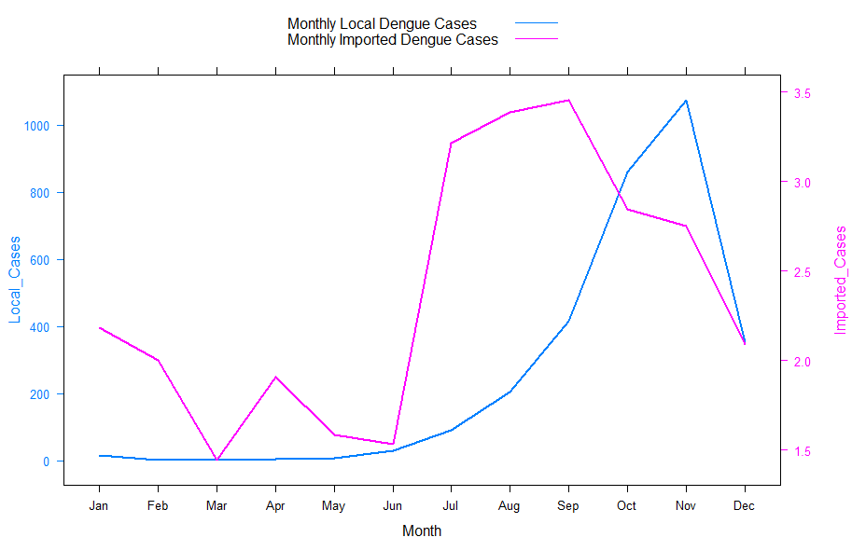

**xyplot-monthly local & imported correlection**

* src: “code for line plot.R”
* data: “1999-2015 Kaohsiung+Tainan_local+import_mothly average.csv”

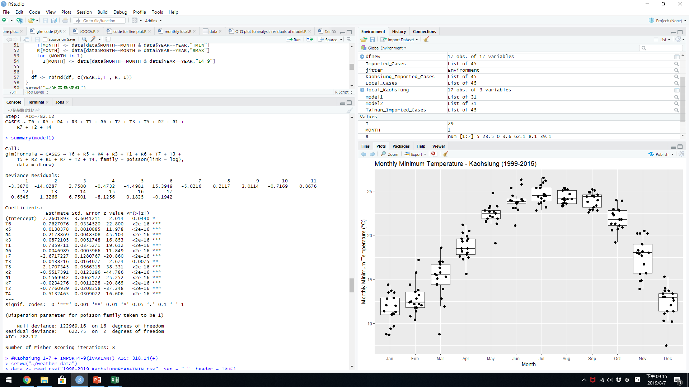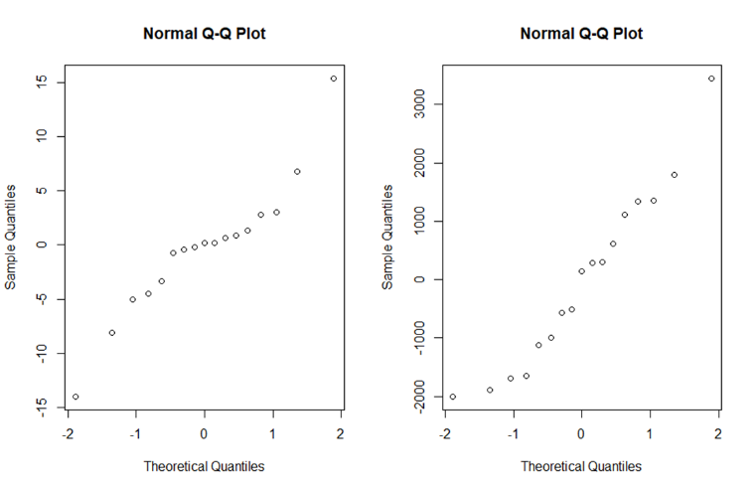

* src: “glm code (2).r”
* data: "1998-2019 KaohsiungRMAX+TMIN.csv"

"1999-2015 L4-Kaohsiung+Tainan.csv"